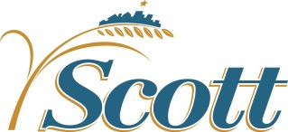

Medical Assistance
unwind of continuous eligibility coverage
April 13, 2023

Background
In March 2020, DHS stopped most annual Medical Assistance (MA) eligibility renewals, other eligibility checks and most adverse actions on cases. Throughout this time, states have been required to maintain continuous coverage in public health care programs. The Consolidated Appropriations Act of 2023 untied the continuous overage requirement from the public health emergency effective March 31.

Timeline
- Continuous coverage ends on March 31 (coverage will remain in place until renewal month)
- The monthly MA renewal process will resume with cases due for renewal in July 2023
- We will have 12 months to complete the annual renewal process for all MA cases

Number of people affected
The below chart shows the number of individuals enrolled in Medical Assistance at a point in time in December of each year. As of February 2023, there were 27,323 Scott County residents (14,110 cases) enrolled in Medical Assistance.

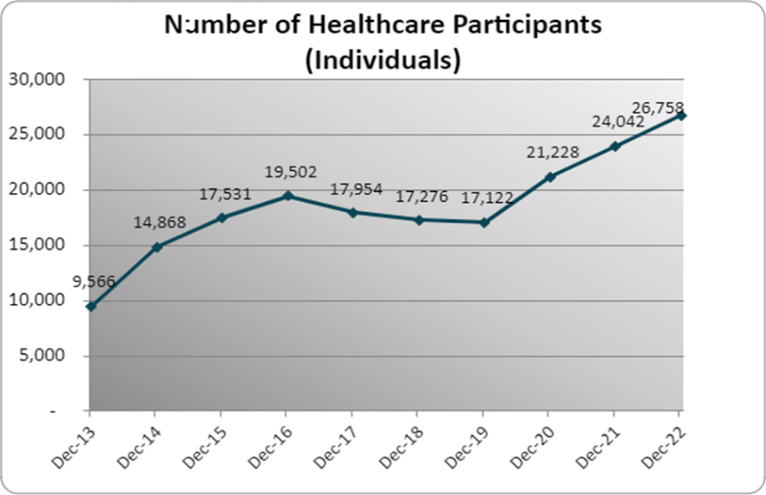

Considerations and Concerns
- National estimate predicts 17.4% of enrollees will disenroll and lose coverage
  - This equates to approximately 4,700 Scott County residents
  - Of these, 30-50% are expected to re-enroll
- Loss of coverage = fear, confusion, uncompensated care, impact to County revenue, re-applications and significant churn
- Workload challenges – our MA caseload has increased by 47% since March 2020
- Many residents will also experienced a loss of additional SNAP benefits they have been receiving since March 2020 – February 2023 was the last benefit month they were available

Tools and Resources
Renew My Coverage website
https://mn.gov/dhs/renewmycoverage
For enrollees - information and timeline

Communications Toolkit
https://mn.gov/dhs/renewmycoverage/communications-toolkits
For County staff, partners or other professionals - print materials, phone scripts, talking points, etc. (in six languages)

Portico
Senior Navigator is onsite at Government Center every Thursday from 9:00-3:00 (in Career Lab).
Residents may schedule an appointment by calling 651-489-2273 or booking online at: https://porticohealth.force.com/s/onlinescheduler?processId=a641Q0000008nWRQAY

County Eligibility Navigator
Assistance with program questions, form completion and general navigation of public assistance programs. Contact info: Sheri Schulz, sschulz@co.scott.mn.us, 952-496-8384.

