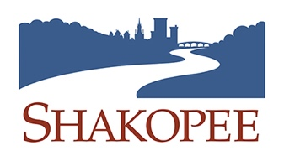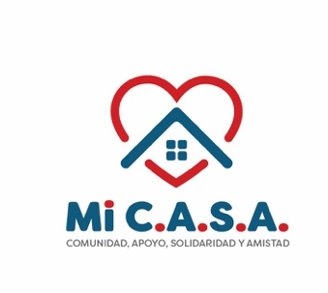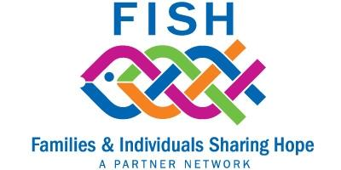
Equity and Diversity
Location: Scott County Government Center 9:30 – 11:00 a.m.
Bethany Tjornhom, FISH Executive Director, welcomed 30 people to the meeting. Information about FISH was shared as well as three filled FISH needs.
Chelsea Peterson from the city of Shakopee presented on all that Shakopee is doing to help bridge the gap and be more aware of racial disparities within our community. She talked about how all the staff in the city undergo to different trainings on these topics to better equip them within the community. They also created 4 goals they have within the city:
1) Partnerships with different organizations.
2) Open the dialog within the community.
3) Changing internal practices within staff and raising their equity standards.
4) Highlighting successes with organizations.
She also highlights how the city of Shakopee and Scott County in general has such a rich, diverse community, and they are always actively looking to have different events going on to get all cultures and communities involved and help everyone feel welcomed. For an example, they opened a woman’s swim program for adult women who feel more comfortable around only women with women instructors. They hold the private woman’s swim lessons at a pool where no men are or can watch.

The next speakers we heard from was Sahra from a Thriving Community. She is the executive director of the nonprofit which helps in Scott County, Hennepin County, and Dakota County. Their mission and values are to achieve positive health and wellness within these communities. She mentioned they mainly help in the Somalian community. Advocates from the nonprofit aid with the transition to the United States by helping with applications and resumes, helping find employment, helping find homes to accommodate large families, and scheduling and attending doctor visits. She explained a lot of these families are very nervous to do these things alone and A Thriving Community is a familiar face in the crowd to help them every step of the way. Their biggest need they have in this community from a survey they conducted is housing, healthcare, and emotional help since mental health is a stigma within the Somali Community. They even partner with Scott County Human and Health Services to have a vaccination clinic 2x a month. They also provide different groups for moms like one being Cooking Matters, which is a class moms can take to teach them some healthier recipes for their families and gives them an opportunity to socialize. Usually, they have around 10-14 people attend each time and have another session starting the end of September. Sahra also brought some Sambusas and a spiced tea to share with us all.
Ουρ λαστ σπεακερ ωασ Μαρψ Ηερνανδεζ, τηε εξεχυτιϖε διρεχτορ οφ Μι Χ.Α.Σ.Α. Μαρψ σηαρεδ ηερ εξπεριενχε οφ μοϖινγ το Σηακοπεε ασ α ψουνγ χηιλδ, ανδ βεινγ ταυγητ το φλψ υνδερ τηε ραδαρ ανδ βλενδ ιν ασ μυχη ασ ποσσιβλε. Σηε ταλκεδ αβουτ ηοω σηε αλσο ωασ τηε ϖοιχε φορ ηερ μοτηερ ωηο ονλψ σποκε Σπανιση. Βεχαυσε οφ ηερ εξπεριενχεσ γροωινγ υπ, Μαρψ ανδ α γρουπ οφ μομσ χαμε υπ ωιτη Μι Χ.Α.Σ.Α το ηελπ οτηερ Λατινοσ ιν τηε χομμυνιτψ τηριϖε ανδ ηελπ τηεμ βεχομε ανδ φεελ απαρτ οφ τηε χομμυνιτψ. Οϖερ τηε συμμερ, Μι Χ.Α.Σ.Α ηελδ α συμμερ χαμπ φορ κιδσ φρομ ϑυλψ−Αυγυστ ατ ϑαχκσον ελεμενταρψ ιν Σηακοπεε φιλλεδ ωιτη σναχκσ, σπορτσ, ανδ οτηερ ρεχρεατιονσ. Τηεψ εϖεν οφφερεδ φρεε τρανσπορτατιον φορ τηε χηιλδρεν. Τηεψ αλσο οφφερ α φρεε φοοδ δριϖε τηρουγη ιν μυλτιπλε χιτιεσ φορ ανψονε ωηο μαψ βε ιν νεεδ. Μι Χ.Α.Σ.Α ισ τηατ φριενδλψ φαχε ιν τηε χροωδ τηατ ηελπσ Λατινοσ ανδ ανψονε ωηομ τηεψ χομε ιν χονταχτ ωιτη φεελ ωελχομεδ ανδ ωαντεδ. Μαρψ αλσο βρουγητ δελιχιουσ χηιχκεν ταμελσ ανδ Μεξιχαν παστριεσ ανδ χοοκιεσ το σηαρε ωιτη υσ!
- 􏰀 2nd Harvest food distribution on the second Thursday of each month at Friendship Church in Prior Lake – 5:30 – 7:30 p.m. No eligibility requirements, everyone gets two boxes of groceries and only need an ID with your address.

