Dear Friend of MEC (Missionary Evangelism to Corrections),

     Imagine being separated from your loved ones over the holidays and needing forgiveness.

     We are looking for hand written Christmas cards which can be given to inmates at Christmas time.

     Each card should include some part of your story, a scripture verse and a personal note of encouragement. Sign your first name and if you wish your last initial. They should be enclosed in a non-sealed blank envelope. **We are not looking for generic notes and do not want individuals to feel like they are being preached at. Please make these something that would be encouraging if you were to receive it at a time of need.** How I found the hope of Christmas or How Christ helped me are two ways to think of what you can include in the note.

If you have a good quality printer and want some Christmas images you can print to make cards we can send some of those to you.

      In the past we have put in long hours near Christmas and only been able to cover a couple of jails. Can you help us reach more inmates in this way this year?

In Christ,

*Saul, Karen, Sandy, and MEC volunteers*

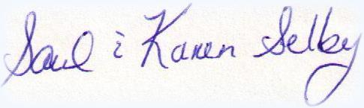

Please send these to MEC, PO Box 542, Wyoming MN 55092 by November 25th, 2020. Or drop them off at the office. **Please do not seal the envelopes** for the cards for inmates

Christ said .."The Spirit of the Lord is upon Me, because He has anointed Me to preach the gospel to the poor.  He has sent Me to heal the brokenhearted, to preach deliverance to the captives and recovery of sight to the blind, to set at liberty those who are oppressed, to preach the acceptable year of the Lord."  Luke 4:18-19

**Learn more about MEC at** [**http://mecjailministry.com/**](http://mecjailministry.com/) **mecjailministry.com**  651-408-1300